Shri Shamrao Patil (Yadravkar) Educational & Charitable Trust’s
SHARAD INSTITUTE OF TECHNOLOGY
POLYTECHNIC, YADRAV.

DEPARTMENT OF INFORMATION TECHNOLOGY
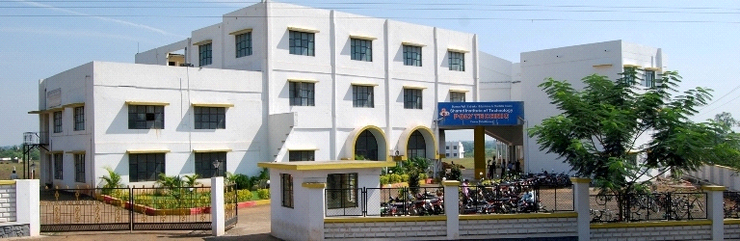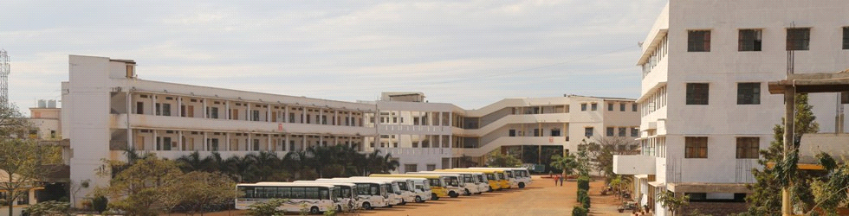
MICRO PROJECT PROPOSAL
IN
GUI Application Development Using VB.net
FOR
2019-20

Part a Plan
Micro Project Proposal

Title of micro project :- Library Management System using VB.net.

- Aim /Benefits of the micro-project:-
- To get the knowledge of different controls in VB.net .
- To collect videos for how to create forms and attach database to the project.
- To get information about new functions and controls require for our coding.
- To study about that SQL database and also new header lines.

- Course outcome :-
- Use Visual Studio IDE to design application.
- Develop GUI Application using Form Controls and its events.
- Use Data Access Control to store data in database and retrieve it.

- Proposed Methodology :-
- First we form our groups.
- Then we suggest the project names to our project guide.
- Then our madam given us project name as Library Management System in VB.net.
- Then we have searched information about coding of library management System in VB.net.
- After searching the information we will download the software visual studio 2012
- After that we will sure that our information is true or false from our project guide.
- Then we will start to create our project . Also we will get information about new controls which we will use in our project.
- And then we will download the videos which are related to project.
- Then we will study about new controls and new header lines which we will use during project.
- And again we will show this information to our project guide.
- Then we will show those video.
- Then finally we will start to create our forms.
- After that we will distribute the project work in group members. Then we will create temporary form and then we will connect the database.
- After that we will show the temporary forms coding of our project to our guide & take some suggestions.
- Then after give some suggestions we will create our final coding using Visual Studio 2012 software.
- And then submit our project to our project guided.

Action plan:-

Sr. no | Activity | Planned start  date | Planned finish  date | Name of responsible  team member
1) | .  First we form our groups. |  |  | 1)Shweta Deepak Bhosale  2)Shreya Shrimandhar Demapure  3)Shabdali Suresh Shetty
2) | Then we suggest the project names to our project guide. |  |  | 1)Shweta Deepak Bhosale  2)Shreya Shrimandhar Demapure  3)Shabdali Suresh Shetty
3) | Then our mam gives us project name as Library Management System in VB.net. |  |  | 1)Shweta Deepak Bhosale.  2)Shreya Shrimandhar Demapure  3)Shabdali Suresh Shetty
4) | Then we will search information about coding of library management System in VB.net. |  |  | 1)Shweta Deepak Bhosale  2)Shreya Shrimandhar Demapure  3)Shabdali Suresh Shetty
5) | After searching the information we will download the software visual studio 2012 |  |  | 1)Shweta Deepak Bhosale  2)Shreya Shrimandhar Demapure  3)Shabdali Suresh Shetty
6) | After that we will sure that our information is true or false from our project guide. |  |  | 1)Shweta Deepak Bhosale  2)Shreya Shrimandhar Demapure  3)Shabdali Suresh Shetty
7) | Then we will start to create our project . Also we will get information about new controls which we will use in our project. |  |  | 1)Shweta Deepak Bhosale  2)Shreya Shrimandhar  Demapure  3)Shabdali Suresh Shetty
8) | And then we will download the videos which are related to project. |  |  | 1) Shweta Deepak Bhosale  2)Shreya Shrimandhar  Demapure  3)Shabdali Suresh Shetty
9) | Then we will study about new controls and new header lines which we will use during project. |  |  | 1)Shweta Deepak Bhosale  2)Shreya Shimandhar Demapure  3)Shabdali Suresh Shetty
10) | And again we will show this information to our project guide. |  |  | 1)Shweta Deepak Bhosale.  2)Shreya Shrimandhar Demapure  3)Shabdali Suresh Shetty
11) | Then we will show those video. |  |  | 1)Shweta Deepak Bhosale  2)Shreya Shrimandhar Demapure  3)Shabdali Suresh Shetty
12) | Then finally we will start to create our forms. |  |  | 1)Shweta Deepak Bhosale  2)Shreya Shrimandhar  Demapure  3)Shabdali Suresh Shetty
13) | After that we will distribute the project work in group members. Then we will create temporary form and then we will connect the database. |  |  | 1)Shweta Deepak Bhosale  2)Shreya Shrimandhar  Demapure  3)Shabdali Suresh Shetty
14) | After that we will show the temporary forms coding of our project to our guide & take some suggestions. |  |  | 1)Shweta Deepak Bhosale  2 )Shreya Shrimandhar Demapure  3)Shabdali Suresh Shetty
15) | Then after give some suggestions we will create our final coding using Visual Studio 2012 software. |  |  | 1)Shweta Deepak Bhosale  2)Shreya Shrimandhar Demapure  3)Shabdali Suresh Shetty
16) | And then submit our project to our project guided. |  |  | 1) Shweta Deepak Bhosale  2)Shreya Shrimandhar Demapure  3)Shabdali Suresh Shetty

- Resource required :
Sr no | Name of recourses | Specification | Quantity | Remark
1) | Computer system | Windows 7 ultimate | 4 | It is used to  Create report & proposal
2) | Software | Visual Studio 2012 | 4 | It is used to  Create coding of project
2) | Browser | https://en.wikipedia.org/wiki/Library management System in VB.net/ | _ | It is used to search the information

- Name of Student :- Roll No

- Shweta Deepak Bhosale. 12504

- Shreya Shrimandhar Demapure. 12507

- Shabdali Suresh Shetty 12521

